Friday | May 16th. 2025 |  |  |  | Issue 01
THE DAILY BUD
 | THE DIGITAL NEWSPAPER
 |  |  |  | Breaking news  The latest local news  -------------- Mikkicee Manning  Video provides a powerful way to help you prove your point. When you click Online Video, you can paste in the embed code for the video you want to add.  To make your document look professionally produced, Word provides header, footer, cover page, and text box designs that complement each other.  For example, you can add a matching cover page, header, and sidebar. Click Insert and then choose the elements you want from the different galleries. Themes and styles also help keep your document coordinated. When you click Design and choose a new Theme.  Save time in Word with new buttons that show up where you need them. To change the way a picture fits in your document, click it and a button for layout options appears next to it.  When you work on a table, click where you want to add a row or a column, and then click the plus sign.You can also type a keyword to search online for the video that best fits your document.  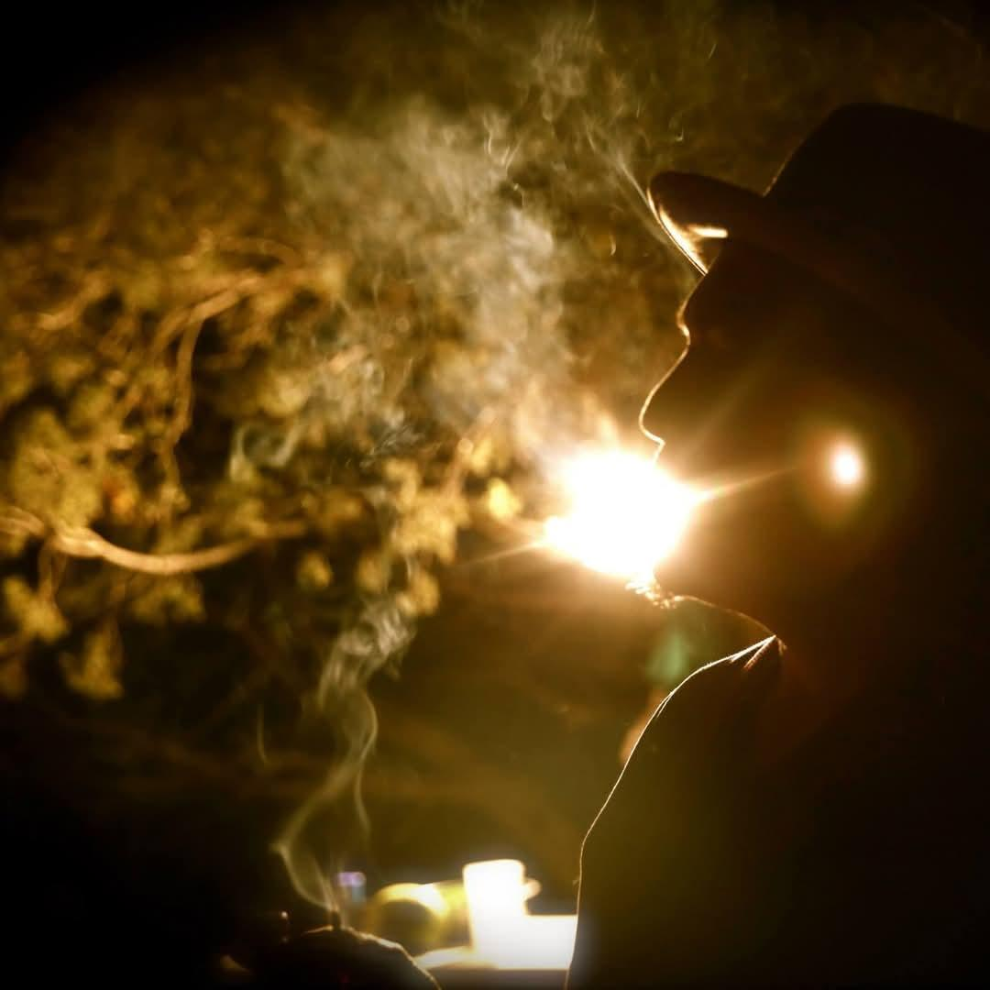  Picture Caption: To make your document look professionally produced, Word provides header, footer, cover page, and text box designs that complement each other.
Picture Caption: To make your document look professionally produced, Word provides header, footer, cover page, and text box designs that complement each other.
Cuberos Scene Lights up
With Cannabis Infused Cuisine
-------------- Mikkicee Manning |  | The soft opening event was a glimpse into the future of dining. Attendees savored dishes like \[mention a specific dish], a testament to the chef's skill in balancing flavor and effect. As the cannabis market in New Mexico evolves, The Hub stands as a pioneering establishment, committed to quality, education, and a unique culinary experience.
Nestled in the small town of Cubero, New Mexico, a culinary revolution is quietly unfolding. The Hub, a new venue, recently held its soft opening, introducing locals to an innovative concept: cannabis-infused cuisine. Spearheaded by a passionate chef with a background in \[mention culinary background if known], this venture aims to elevate dining in Cubero with carefully crafted dishes that blend local flavors with the nuanced effects of cannabis.

The chef's journey into cannabis-infused cooking is a story of culinary exploration and a desire to push boundaries. With a deep appreciation for New Mexico's local ingredients, they've created a menu that highlights the region's unique flavors while incorporating precise cannabis dosing for a safe and enjoyable experience. The Hub isn't just a restaurant; it's an educational space where customers can learn about responsible consumption and the potential of cannabis in culinary arts.

Tuesday Sep 23, 20XX
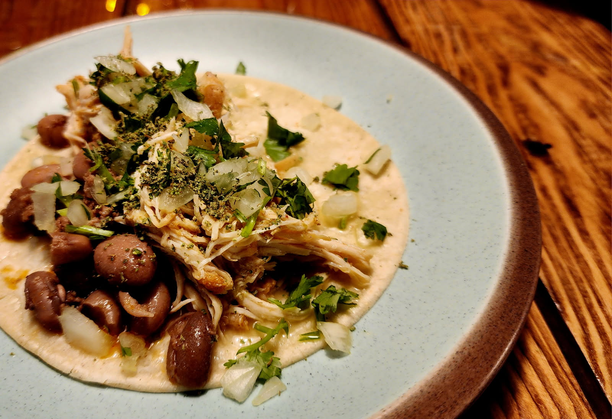 |  |  |  | Breaking news  The latest local news  -------------- MIRJAM NILSSON  Reading is easier, too, in the new Reading view. You can collapse parts of the document and focus on the text you want. If you need to stop reading before you reach the end, Word remembers where you left off - even on another device.  To make your document look professionally produced, Word provides header, footer, cover page, and text box designs that complement each other.  Video provides a powerful way to help you prove your point. When you click Online Video, you can paste in the embed code for the video you want to add. You can also type a keyword to search online for the video that best fits your document.  Picture Caption: To make your document look professionally produced, Word provides header, footer, cover page, and text box designs that complement each other.
Infused Street Tacos Photo Credit: Brian Yazzie
The scoop of the year
The latest local news
-------------- MIRJAM NILSSON  Video provides a powerful way to help you prove your point. When you click Online Video, you can paste in the embed code for the video you want to add. You can also type a keyword to search online for the video that best fits your document.  To make your document look professionally produced, Word provides header, footer, cover page, and text box designs that complement each other. For example, you can add a matching cover page, header, and sidebar. Click Insert and then choose the elements you want from the different galleries. |  | Save time in Word with new buttons that show up where you need them. To change the way a picture fits in your document, click it and a button for layout options appears next to it. When you work on a table, click where you want to add a row or a column, and then click the plus sign.  Video provides a powerful way to help you prove your point. When you click Online Video, you can paste in the embed code for the video you want to add. You can also type a keyword to search online for the video that best fits your document. Reading is easier, too, in the new Reading view. You can collapse parts of the document and focus on the text you want.
The next hot and upcoming news story
Breaking news from your local trusted source
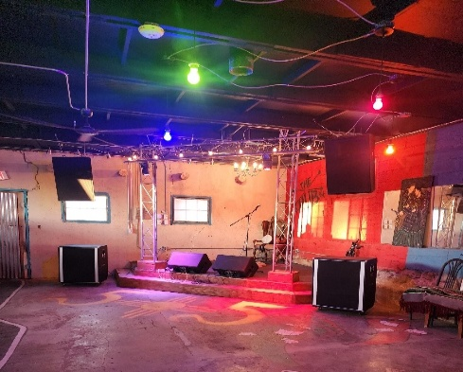 |  | To make your document look professionally produced, Word provides header, footer, cover page, and text box designs that complement each other. For example, you can add a matching cover page, header, and sidebar.  Click Insert and then choose the elements you want from the different galleries. Themes and styles also help keep your document coordinated. When you click Design and choose a new Theme. Video provides a powerful way to help you prove your point. When you click Online Video, you can paste in the embed code for the video you want to add. | Save time in Word with new buttons that show up where you need them. To change the way a picture fits in your document, click it and a button for layout options appears next to it. When you work on a table, click where you want to add a row or a column, and then click the plus sign.  Video provides a powerful way to help you prove your point. When you click Online Video, you can paste in the embed code for the video you want to add. You can also type a keyword to search online for the video that best fits your document.
-------------- MIRJAM NILSSON
Video provides a powerful way to help you prove your point. When you click Online Video, you can paste in the embed code for the video you want to add. You can also type a keyword to search online for the video that best fits your document.
2 |  |  |  |  | Issue 10

Tuesday Sep 23, 20XX
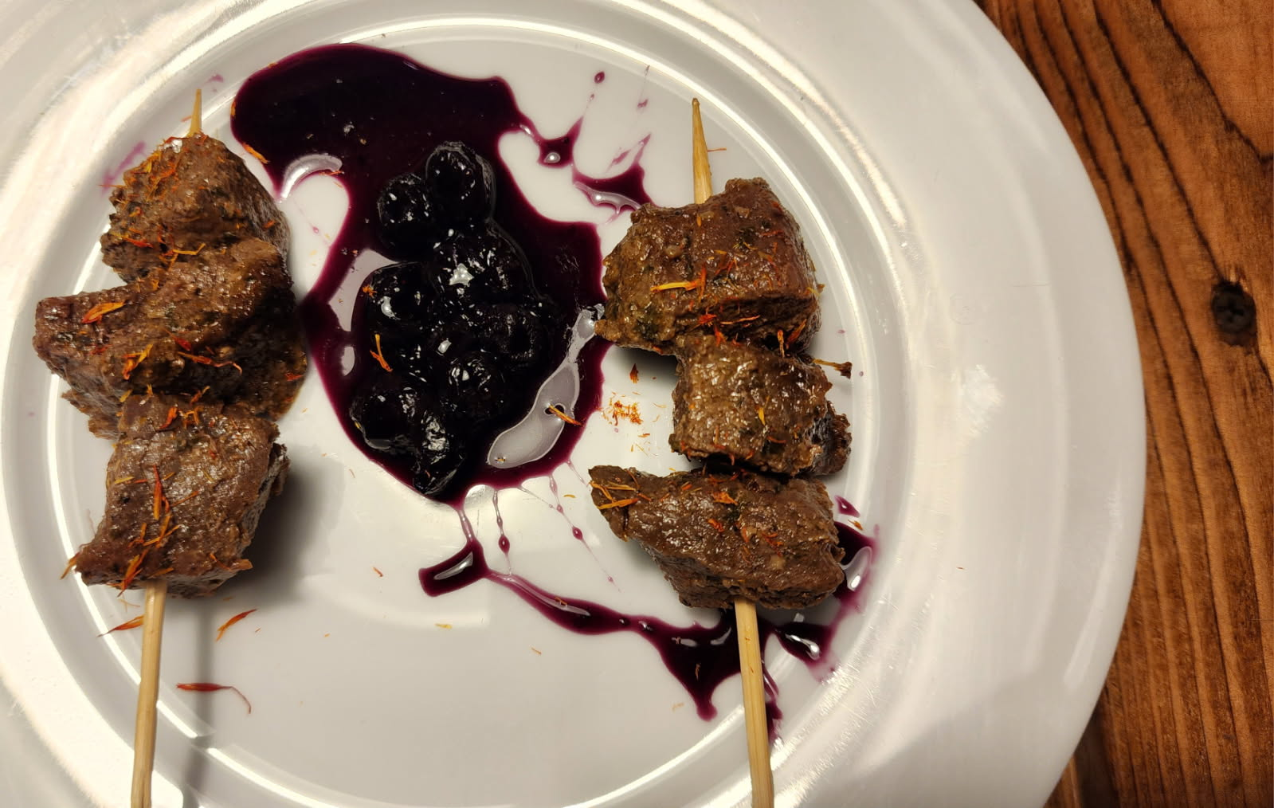
Herb Braised Bison Photo Credit: Brian Yazzie
The next hot and upcoming news story
Breaking news from your local trusted source
-------------- MIRJAM NILSSON  Video provides a powerful way to help you prove your point. When you click Online Video, you can paste in the embed code for the video you want to add. You can also type a keyword to search online for the video that best fits your document.  To make your document look professionally produced, Word provides header, footer, cover page, and text box designs that complement each other. For example, you can add a matching cover page, header, and sidebar. |  |  | Click Insert and then choose the elements you want from the different galleries. Themes and styles also help keep your document coordinated. When you click Design and choose a new Theme.  Reading is easier, too, in the new Reading view. You can collapse parts of the document and focus on the text you want. If you need to stop reading before you reach the end, Word remembers where you left off - even on another device. Themes and styles also help keep your document coordinated.
 |  | keyword to search online for the video that best fits your document. When you work on a table, click where you want to add a row or a column, and then click the plus sign. Video provides a powerful way to help you prove your point. When you click Online Video, you can paste in the embed code for the video you want to add. You can also type a keyword to search online for the video that best fits your document.  To make your document look professionally produced, Word provides header, footer, cover page, and text box designs that complement each other. For example, you can add a matching cover page, header, and sidebar. Click Insert and then choose the elements you want from the different galleries. Themes and styles also help keep your document coordinated.  When you click Design and choose a new Theme. Save time in Word with new buttons that show up where you need them. To change the way a |  | picture fits in your document, click it and a button for layout options appears next to it. Reading is easier, too, in the new  Reading view. You can collapse parts of the document and focus  on the text you want. If you need to stop reading before you reach the end, Word remembers where you left off - even on another device. Themes and styles also help keep your document coordinated.  Video provides a powerful way to help you prove your point. When you click Online Video, you can paste in the embed code for the video you want to add. You can also type a keyword to search online for the video that best fits your document. When you work on a table, click where you want to add a row or a column, and then click the plus sign. When you work on a table, click where you want to add a row or a column, and then click the plus sign. Video provides a powerful way to help you prove your point.
Picture caption: To make your document look professionally produced, Word provides header, footer, cover page, and text box designs that complement each other.
Breaking news
The latest local news

-------------- MIRJAM NILSSON

Video provides a powerful way to help you prove your point. When you click Online Video, you can paste in the embed code for the video you want to add. You can also type a
3 |  |  |  |  | Issue 10

Tuesday Sep 23, 20XX
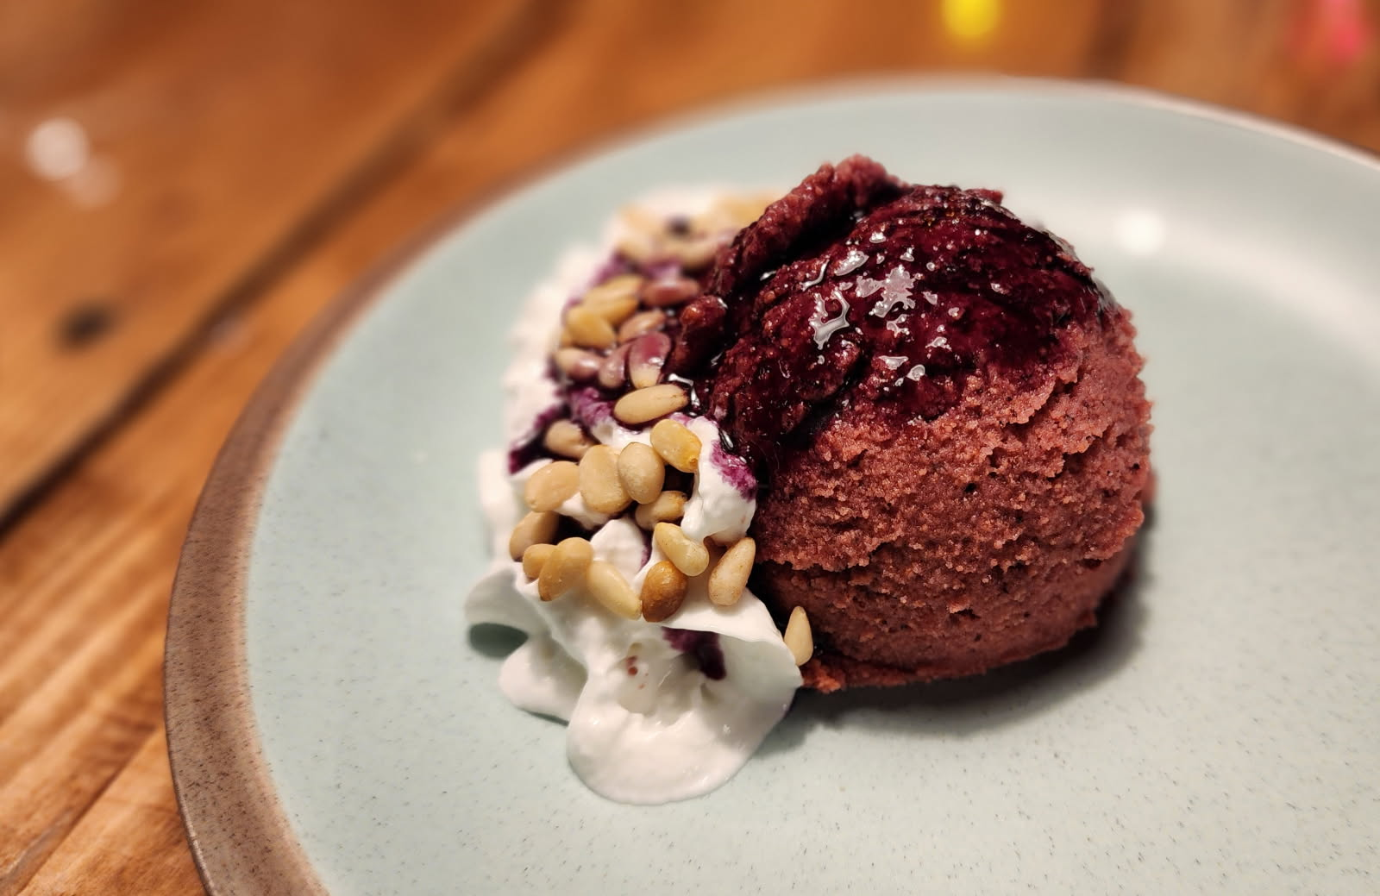
Picture Caption: To make your document look professionally produced, Word provides header, footer, cover page, and text box designs that complement each other.
The next hot and upcoming story
Breaking news from your local trusted source
-------------- MIRJAM NILSSON  Video provides a powerful way to help you prove your point. When you click Online Video, you can paste in the embed code for the video you want to add. You can also type a keyword to search online for the video that best fits your document.  To make your document look professionally produced, Word provides header, footer, cover page, and text box designs that complement each other. For example, you can add a matching cover page, header, and sidebar. Click Insert and then choose the elements you want from the different galleries. Themes and styles also help keep your document coordinated. When you click Design and choose a new Theme.  Save time in Word with new buttons that show up where you need them. To change the way a picture fits in your document, click it and a button for layout options appears next to it. When you work on a table, click where you want to add a row or a column, and then click the plus sign.  To make your document look professionally produced, Word provides header, footer, cover page, and text box designs that complement each other. For example, you can add a matching cover page, header, and sidebar. Click Insert and then choose the elements you want from the different galleries. |  | Video provides a powerful way to help you prove your point. When you click Online Video, you can paste in the embed code for the video you want to add. You can also type a keyword to search online for the video that best fits your document.
“Video provides
a powerful way to
help you prove
your point.”
 |  | Save time in Word with new buttons that show up where you need them. To change the way a picture fits in your document, click it and a button for layout options appears next to it. When you work on a table, click where you want to add a row or a column, and then click the plus sign.
4 |  |  | Issue 10

